
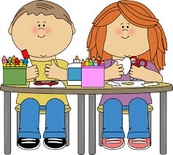
Mrs. Cariola’s Second Grade
Special Schedule
Room B–5

Day 1: Computer
Please bring in headphones (not earbuds) in a Ziplock bag with your child’s name on it. Please be sure headphones fit well and will hold up since they will be used frequently.

Day 2: P.E.
Wear sneakers to school

Day 3: Art
Please bring a shirt for art class (adult size shirts work best) in a ziplock bag with your child’s name on it.

Day 4: Library
Return Library book

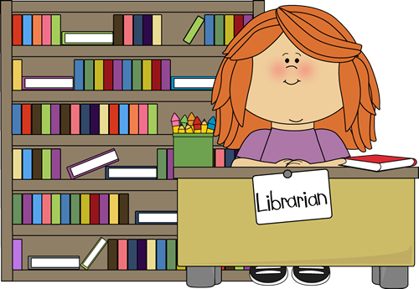
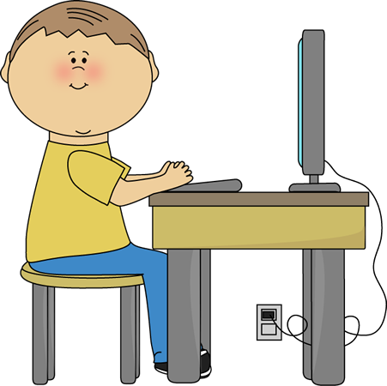
Day 5: Music

